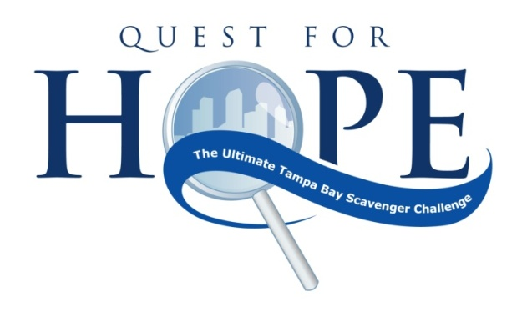
Saturday, September 19, 2020
Italian Club
1731 E 7th Ave
Tampa, FL 33605

To Benefit the 1Voice Foundation

The Krewe of the Nautilus is well into planning the 14^{h} Annual Quest for Hope Scavenger Challenge. Quest for Hope challenges teams, by way of a mobile application, to scavenge their way through historic Ybor City, following clues to answer riddles and complete zany challenges to earn points. Quest for Hope is our annual charity event raising awareness and funds for childhood cancer. Proceeds from Quest for Hope directly benefit 1Voice Foundation.

The CAUSE of the 1Voice Foundation is to support children with cancer and their families by connecting them with financial, emotional and educational CARE while funding research for tomorrow’s CURE.

1Voice Foundation provides over 20 family support programs for pediatric cancer families in the Tampa Bay area. Under the direction of Dr. Cameron Tebbi, M.D., 1Voice also funds and operates a pediatric cancer research lab where a vaccine for leukemia is being developed. Each year the 1Voice legislative committee and pediatric oncology families testify before Congress and the Senate to share their stories and advocate for increased funding for pediatric cancer survivors and research. Hillsborough County Schools has partnered with 1Voice Foundation to launch the 1Voice Academy initiative for the first school in the United States for children with cancer. Since their 2008 inception, 1Voice Foundation has touched the lives of 800 families in our community.

The Krewe of the Nautilus’s mission is to promote Florida environmental awareness and conservation through friendship and association, education, charitable sponsorship and community service. In addition to helping with environmental clean ups, conservation and educational opportunities among various Tampa Bay area organizations including the Tampa Bay Watch & Keep Tampa Beautiful, the Krewe of the Nautilus members participate in multiple events to support the 1Voice Foundation. Quest for Hope is their foremost 1Voice fund raising charity event.

We need your help to create HOPE. Please consider one of the sponsorship opportunities detailed on the enclosed sponsorship commitment form and join us in our endeavor to make a difference.

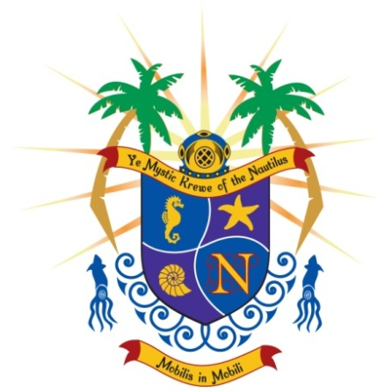

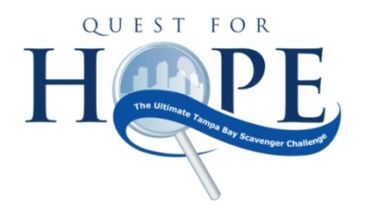
http://kreweofthenautilus.com/sponsors-2/

Sponsorship Opportunities

 | Treasure Seeker Sponsor |  | Extreme Explorer Sponsor |  | Clue Sleuth Sponsor |  | Challenge Sponsor |  | Treasure the Children
Amount | $5,000 |  | $2,500 |  | $1,250 |  | $1000 |  | $500
# participating teams / participants* | 3 / 15 |  | 2 / 10 |  | 1 / 5 |  | 1/5 |  | 1/5
logo placement & Recognition at event & social media# | X |  | X |  | X |  | X |  | X
scavenger challenge naming rights (challenge presented by…) | X |  | X |  | X |  | X
reserved seating & dinner at event party | 15 |  | 10 |  | 5
vip drink tickets | 15 |  | 10 |  | 5
special sponsor appreciation Lunch at 1voice foundaton | 2 |  | 2 |  | 2 |  | 2 |  | 2
tickets to 1voice event of choice | 4 |  | 4 |  | 2 |  | 2
Participate with YMKN At Night Parade or St. Patrick’s Day Parade | 4 |  | 2 |  | 4 |  | 4 |  | 2**
participate with ymkn at gasparilla children’s parade | 4 |  | 4
# Sponsors to provide banner, promotional materials and logos. Deadlines apply.
* Sponsors may create their own teams to participate or allocate 1 or more of their teams back to event coordinators to create teams made
up of oncology parents and/or 1Voice volunteers
** Sponsor may select 1 – Gasparilla Children’s Parade (2 adults, 2 children), Knights of Sant’ Yago Parade (2 adults) OR St. Patrick’s Day Parade (2 adults)

Designated Sponsorship Opportunities
Dinner Sponsor - $1,500
- Sponsor Event dinner purchase
- Receive verbal recognition and logo placement at event
- Marketing materials place in event backpacks.
- Opportunity to place two five person teams in Quest for Hope event
- 4 adults ride float with YMKN at Knights of sant’ yago parade OR rough riders’ st. patrick’s day parade

Enter information on line with http://kreweofthenautilus.com/sponsors-2/

2020 Sponsorship
Company Name:

Contact Person:
Address: City, State Zip:
E-mail address:
Phone number: Fax number:
PLEASE CHECK THE APPROPRIATE SPONSORSHIP LEVEL
Treasure Seeker Sponsor: $5,000
Extreme Explorer Sponsor: $2,500
Clue Sleuth Sponsor: $1,250
Dinner Sponsor $1500
Challenge Sponsor: $1,000
Treasure the Children Sponsor: $500
Donation ___$25 $___50 ___$75 ___$100 ___$250 ___$Other
PLEASE MARK THE APPROPRIATE PAYMENT METHOD
Check is enclosed, made payable Ye Mystic Krewe of the Nautilus;
Memo F/B/O 1Voice Foundation
Please accept our official pledge; will submit full payment no later than September 15,
Please Charge The Following Credit Card (circle one):

VISA AMEX MASTERCARD DISCOVER

Credit Card Number:

Expiration Date: CVV# (3 digit code on back of card):

Name on Card: Signature:

MAIL OR FAX TO: DONOR RETAINS A COPY AS A RECEIPT:
Quest for Hope 501(c) 3 Tax Identification #26-3179244
P.O. Box 22062
Tampa, FL 33622-2062

Contact: Melissa Sigmon 813-417-9804 ▪ siggy104bulls@yahoo.com
IN ACCORDANCE WITH THE FLORIDA SOLICITATION OF CONTRIBUTIONS ACT, WE MUST INFORM YOU THAT A COPY OF THE OFFICIAL REGISTRATION STATEMENT OF YE MYSTIC KREWE OF THE NAUTILUS MAY BE OBTAINED FROM THE DIVISION OF CONSUMER SERVICES BY CALLING TOLL-FREE (1-800-435-7352). REGISTRATION DOES NOT IMPLY ENDORSEMENT, APPROVAL OR RECOMMENDATION BY THE STATE.

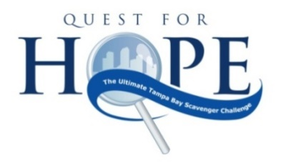

If you will be putting your own team/s in the Quest for Hope Scavenger Challenge, please complete and submit the following information or enter team at http://kreweofthenautilus.com/register/.

If you will be allocating 1 or more of your teams back to event coordinators to create teams made up of oncology parents and/or 1Voice volunteers please indicate “ALLOCATE” in Captain’s name space.

Team 1
Captain’s Name: | Email:
Name: | Email:
Name: | Email:
Name: | Email:
Name: | Email:
Team 2
Captain’s Name: | Email:
Name: | Email:
Name: | Email:
Name: | Email:
Name: | Email:
Team 3
Captain’s Name: | Email:
Name: | Email:
Name: | Email:
Name: | Email:
Name: | Email:
Team 4
Captain’s Name: | Email:
Name: | Email:
Name: | Email:
Name: | Email:
Name: | Email:
Team 5
Captain’s Name: | Email:
Name: | Email:
Name: | Email:
Name: | Email:
Name: | Email:

